Module 3: IAM Policies Assignment
Problem Statement: You work for XYZ Corporation. To maintain thes ecurityof the AWS account and the resources you have been asked to implement a solution that can help easily recognize and monitor the different users.
Tasks To Be Performed:
1. Create policy number1 which lets the users to:
a. Access S3 completely
b. Only create EC2 instances
c. Full access to RDS

2. Create a policy number 2 which allows the users to:
a. Access Cloud Watch and billing completely
b. Can only list EC2 and S3 resources

3. Attach policy number 1 to the Dev Team from task 1
4. Attach policy number 2 to Ops Team from task1

1. Create policy number1 which lets the users to:
a. Access S3 completely
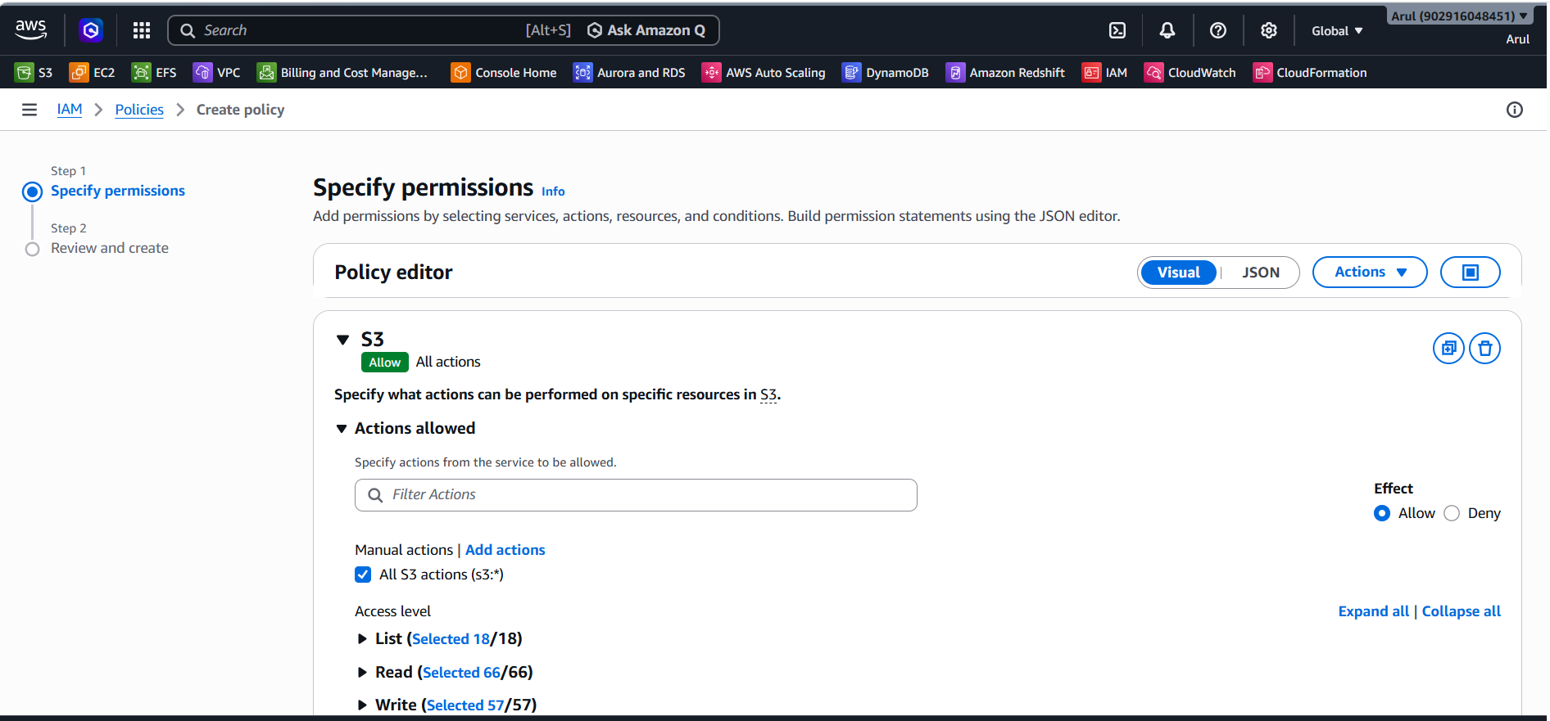
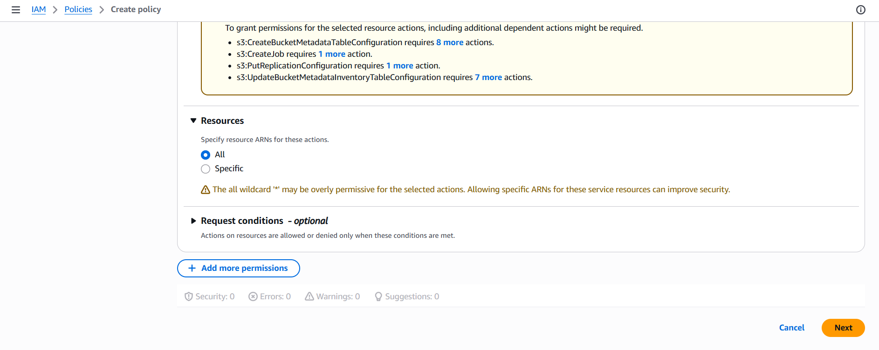
c. Full access to RDS
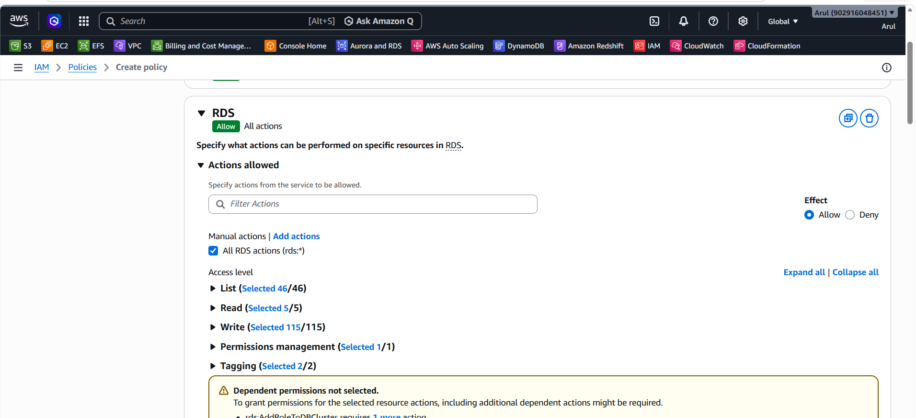

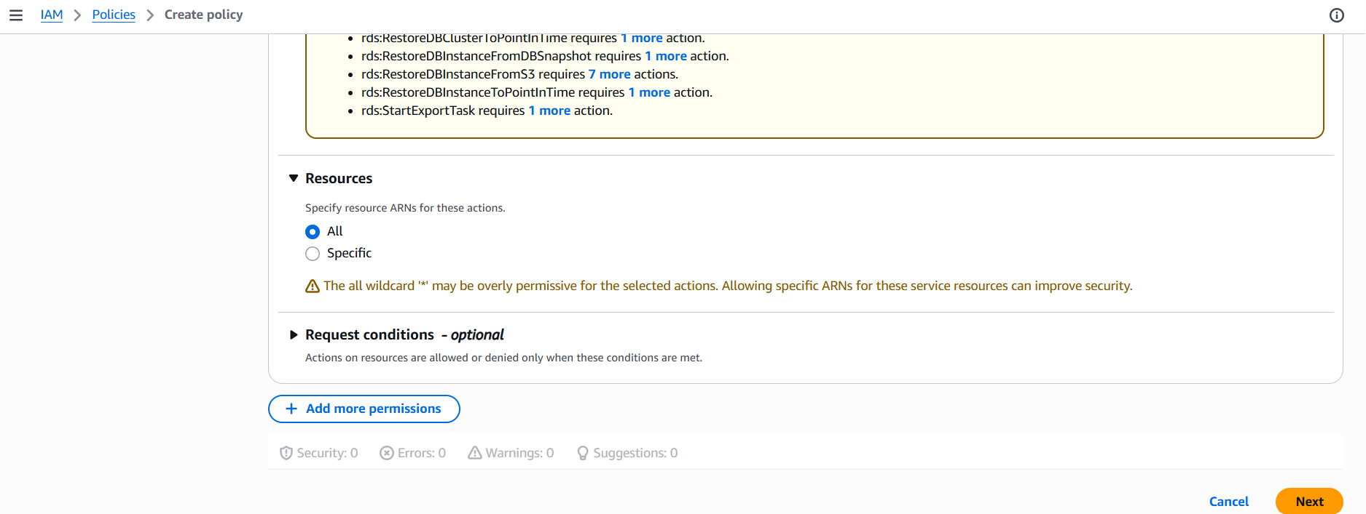
b. Only create EC2 instances
DescribeTags:
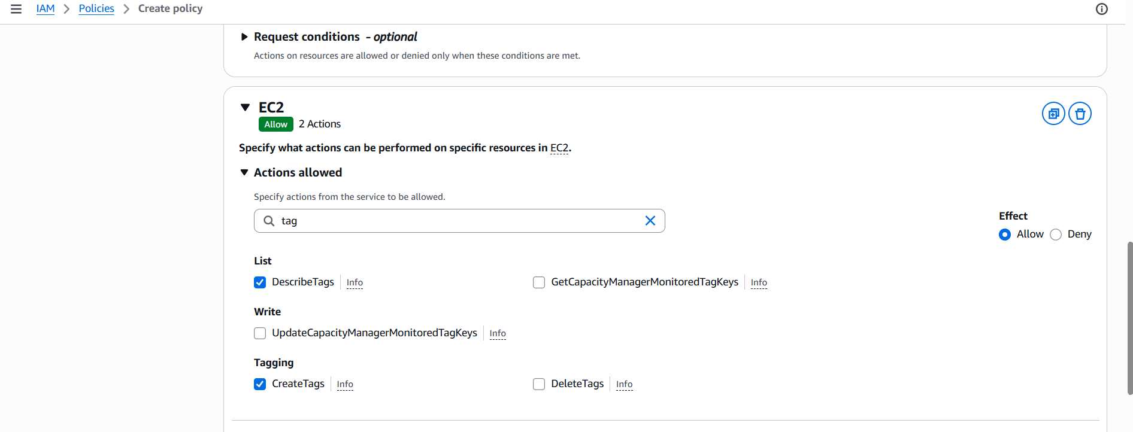
DecribeImages:
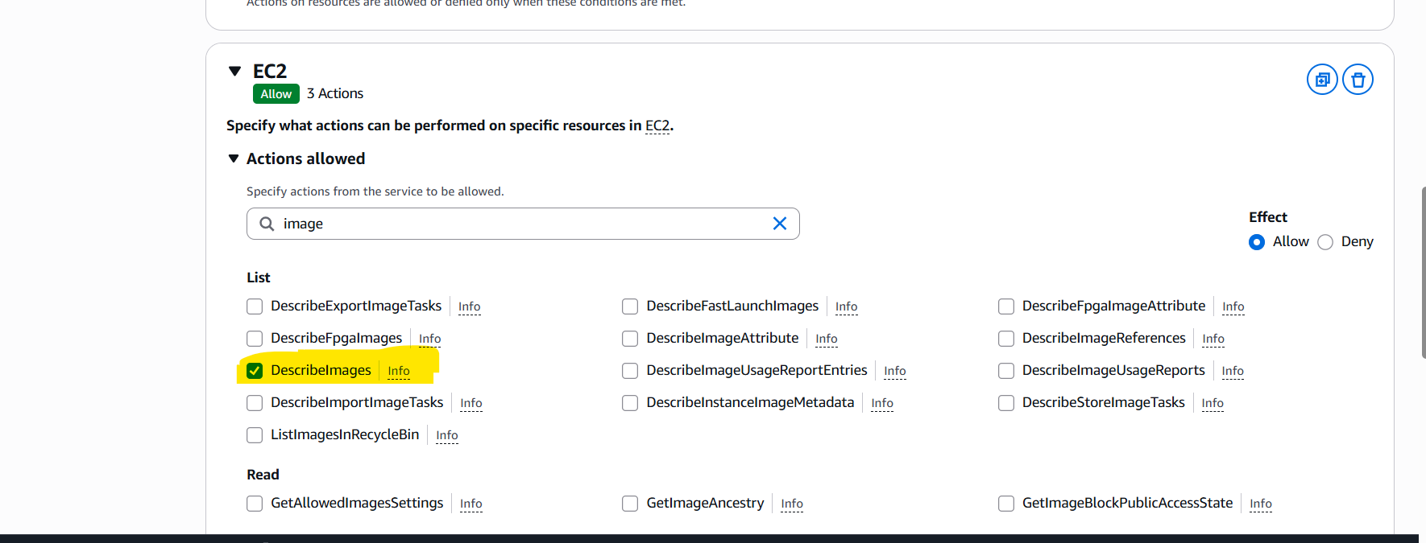
DecribeInstanceType:
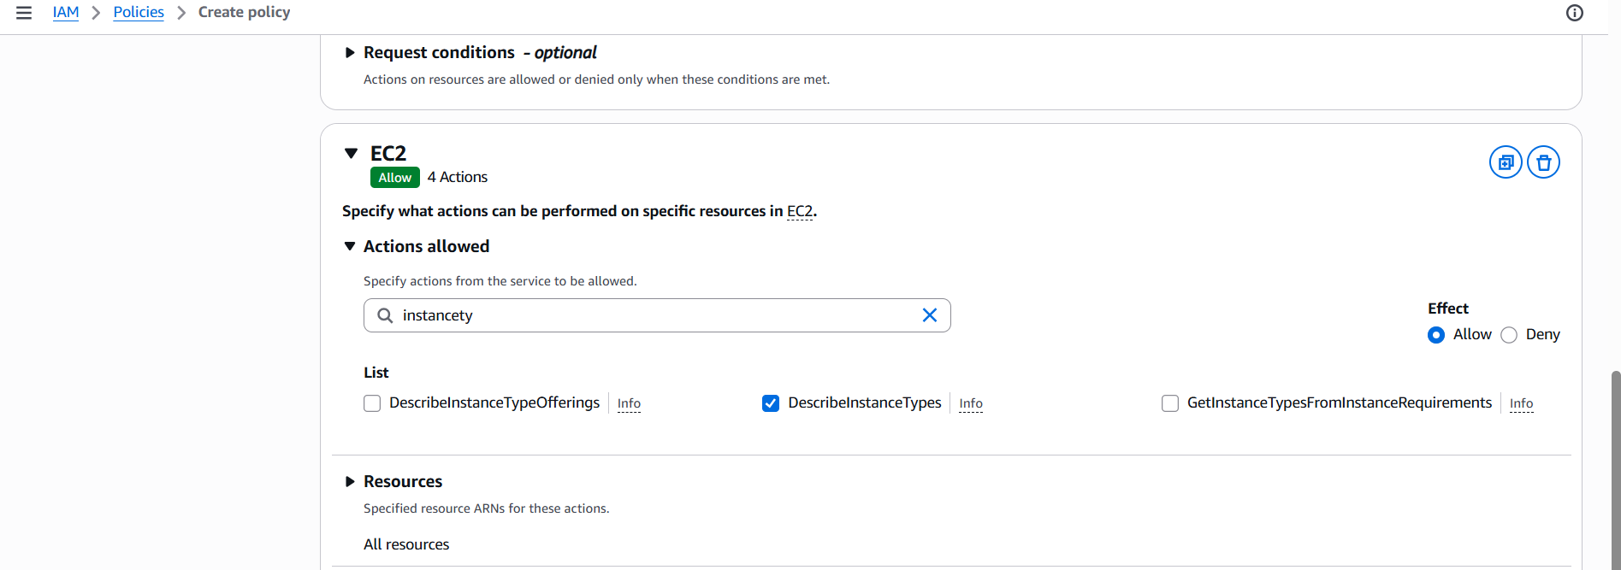
DecribeKeyPairs:
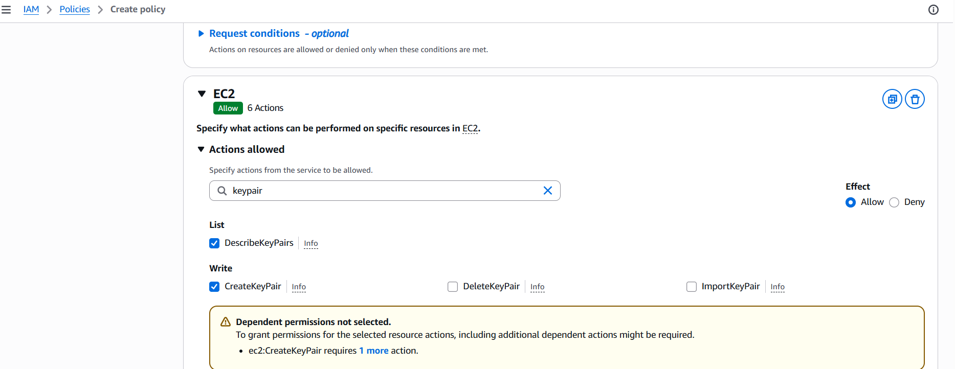
DecribeVpc:
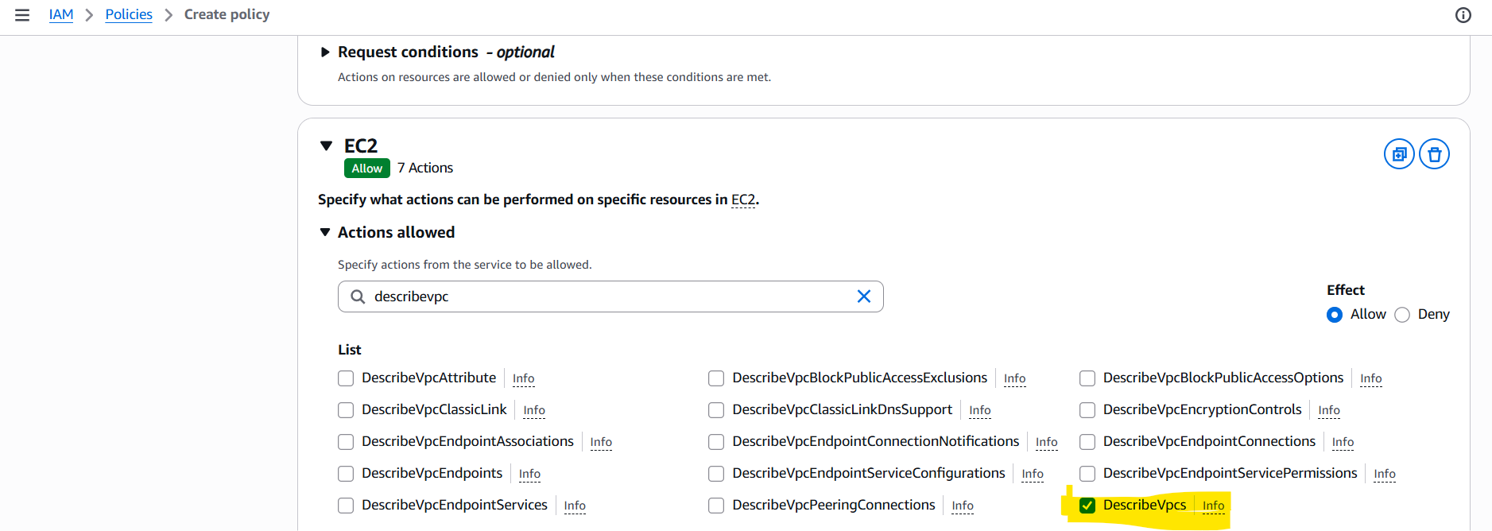
Decribesubnets:
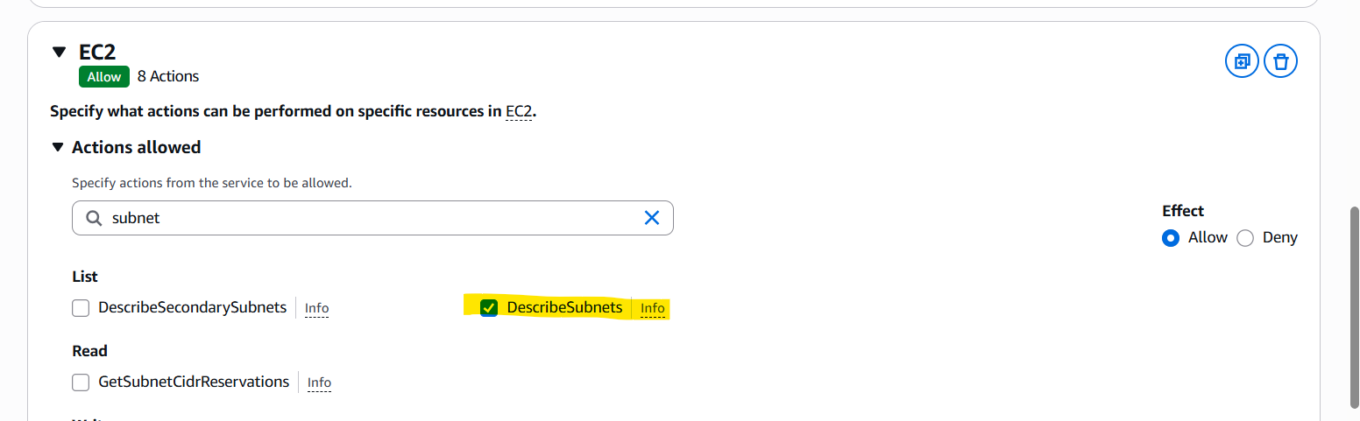
DescribeSecurityGroups:
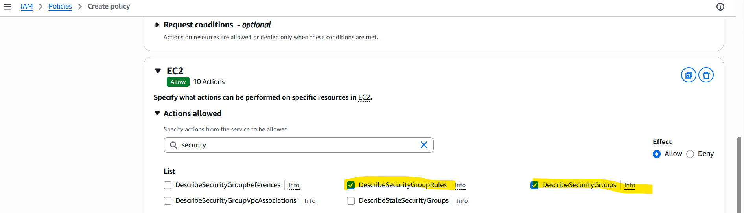
CreateVolumes:
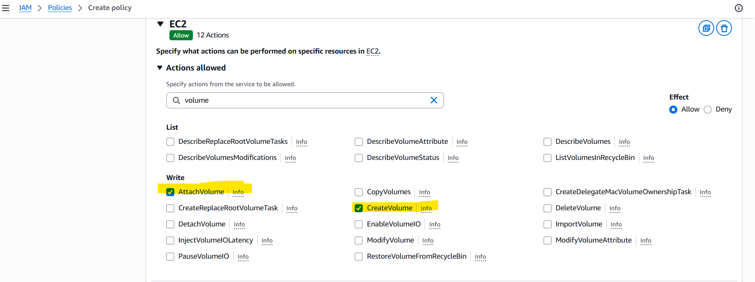
DecribeNetworkInterface:
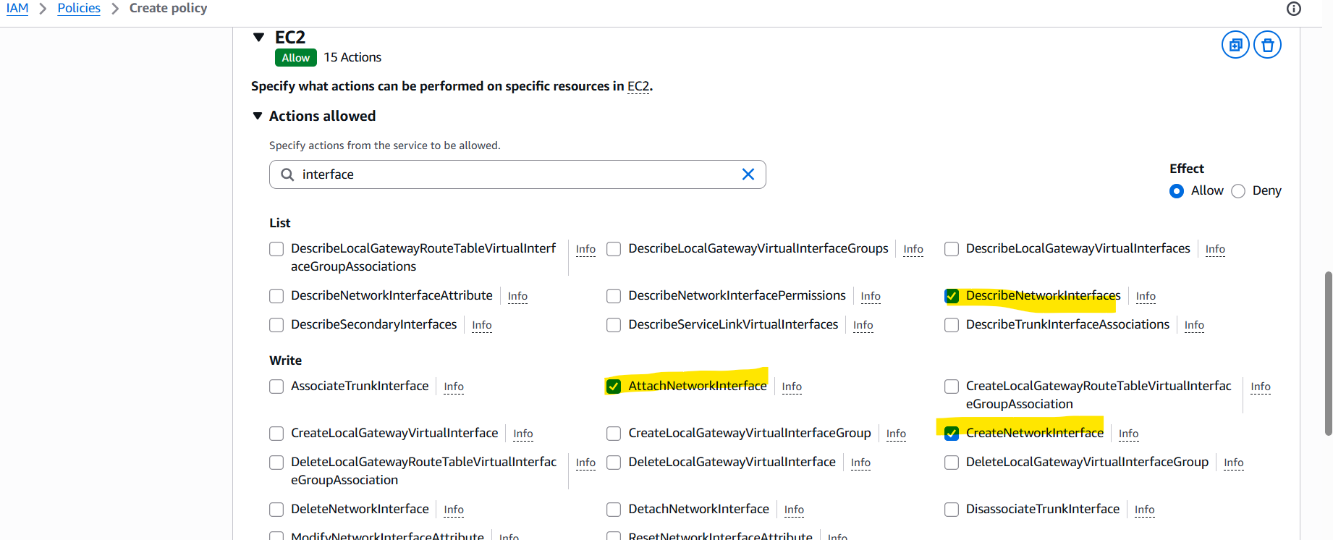
RunInstances:
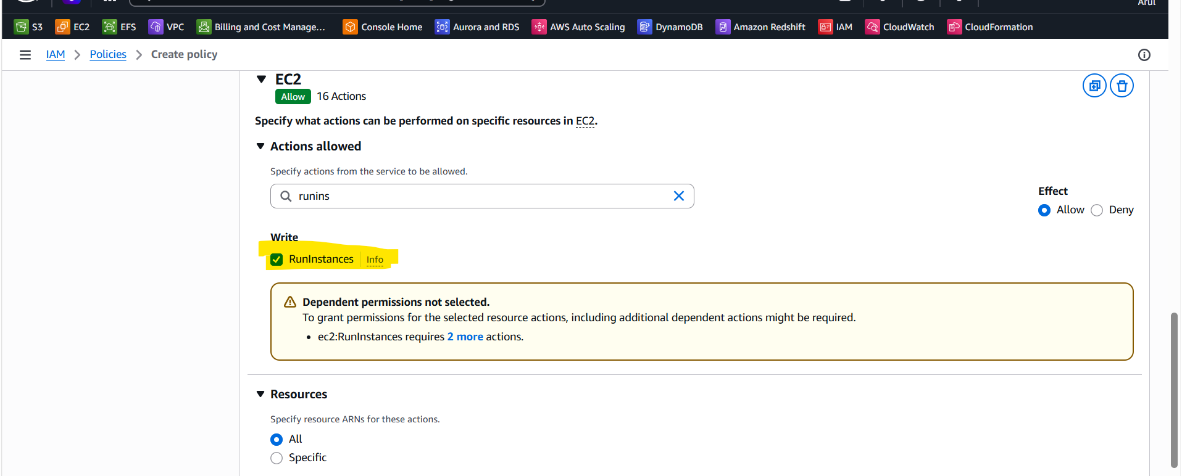

Policy name: Ploicynumer01
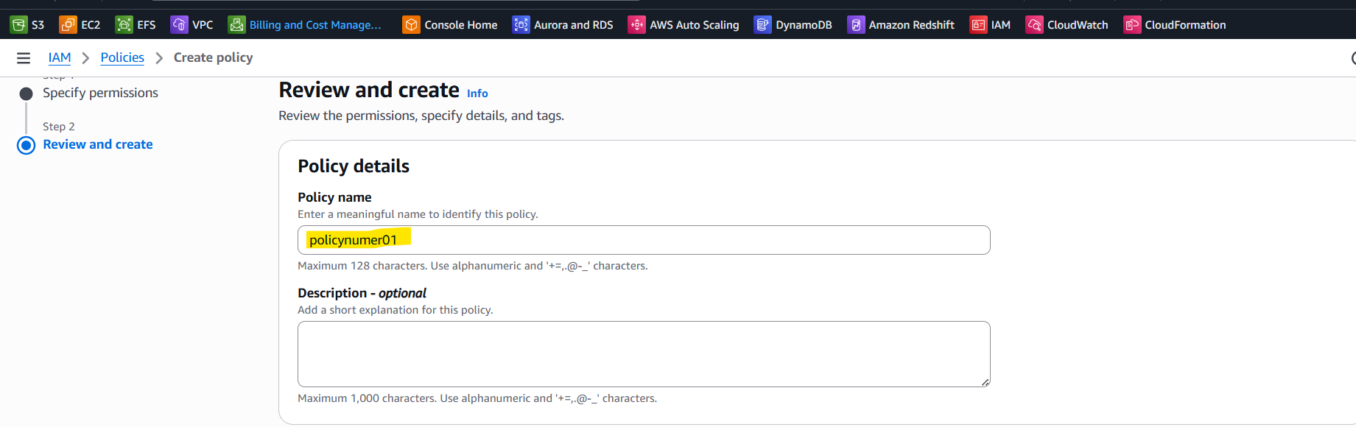

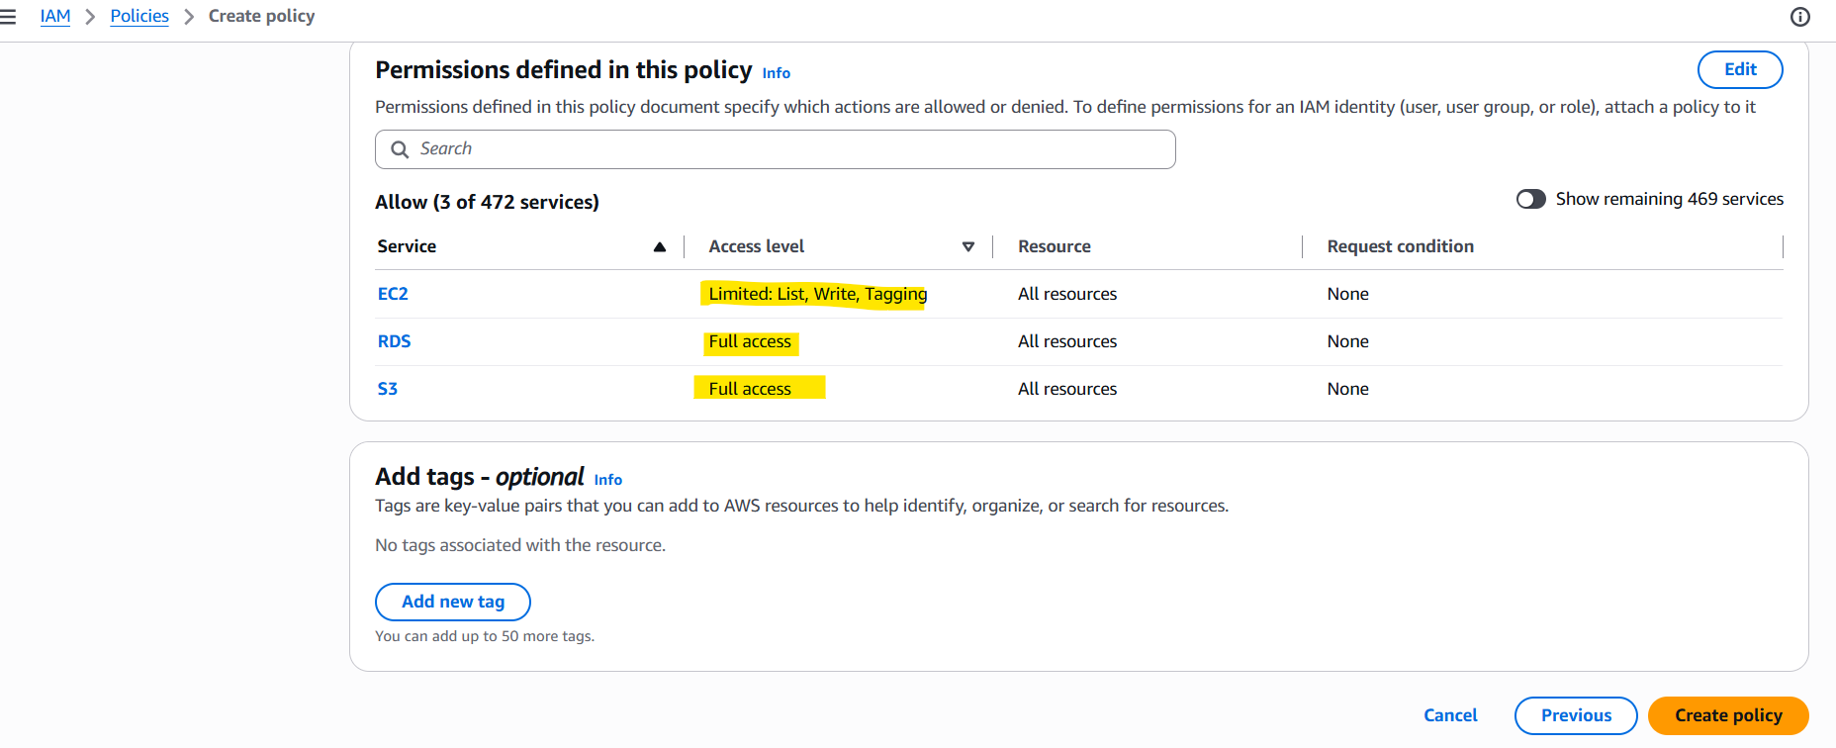
2. Create a policy number 2 which allows the users to:
a. Access Cloud Watch and billing completely
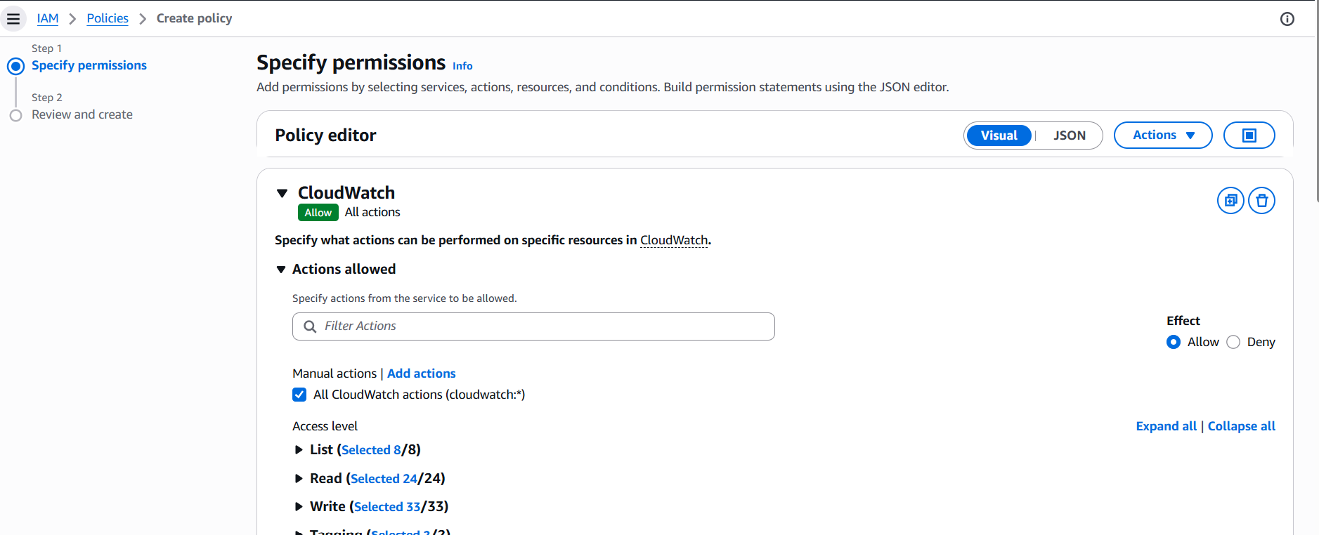
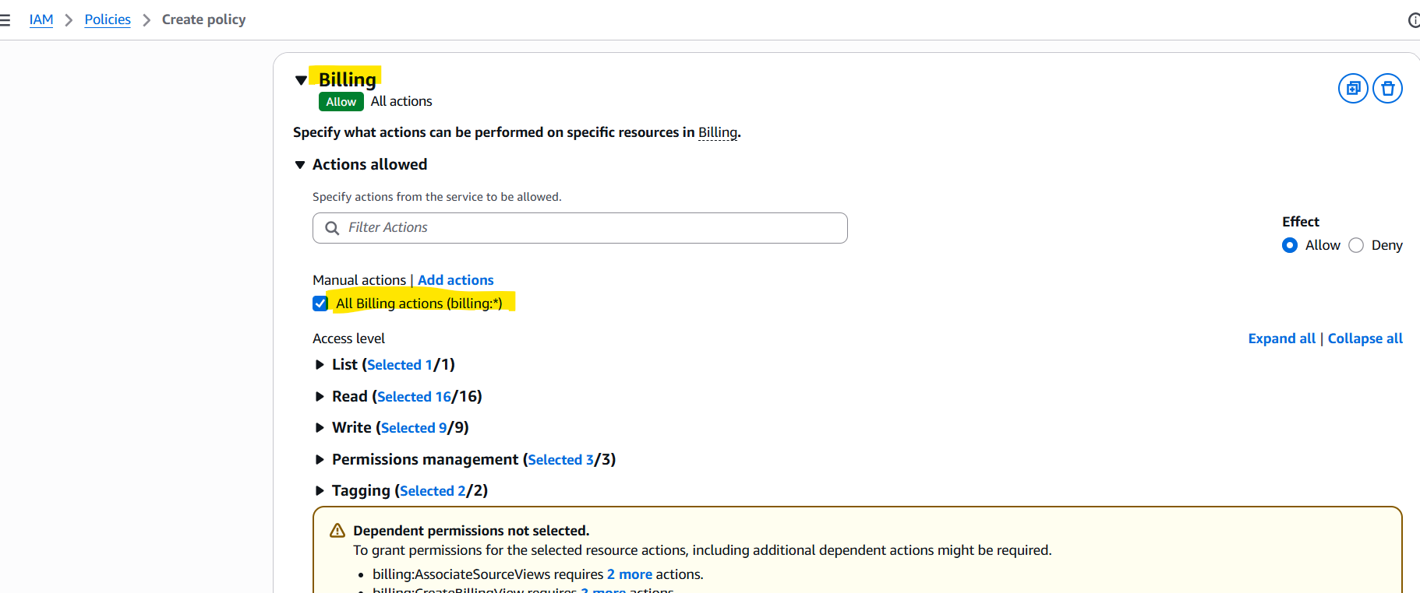
b. Can only list EC2 and S3 resources
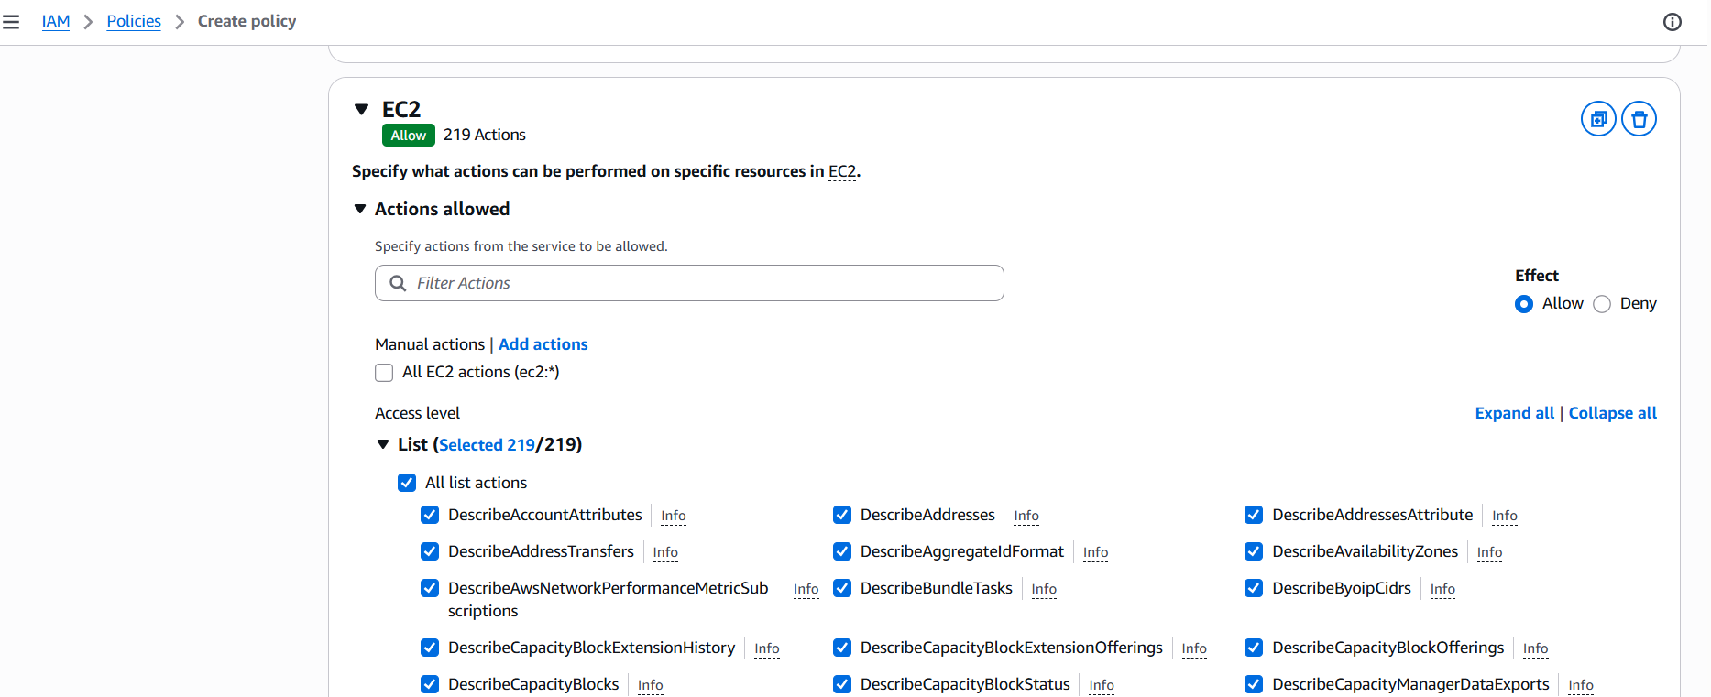
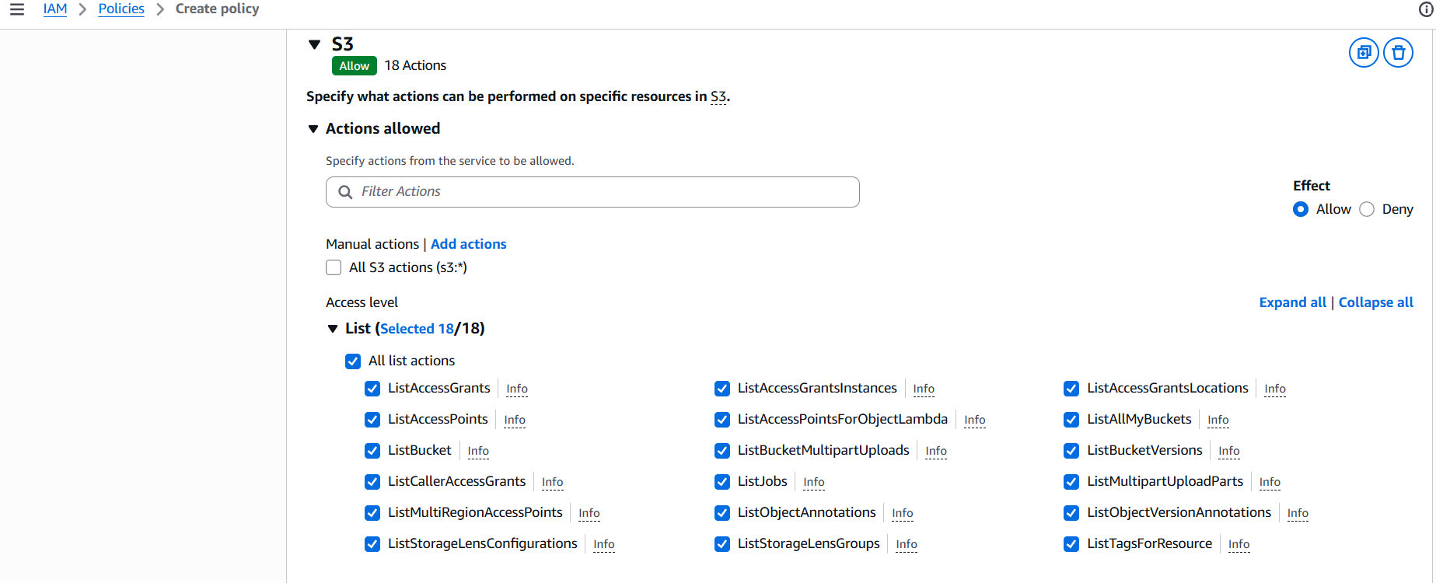
Ploicyname: Policynumber02
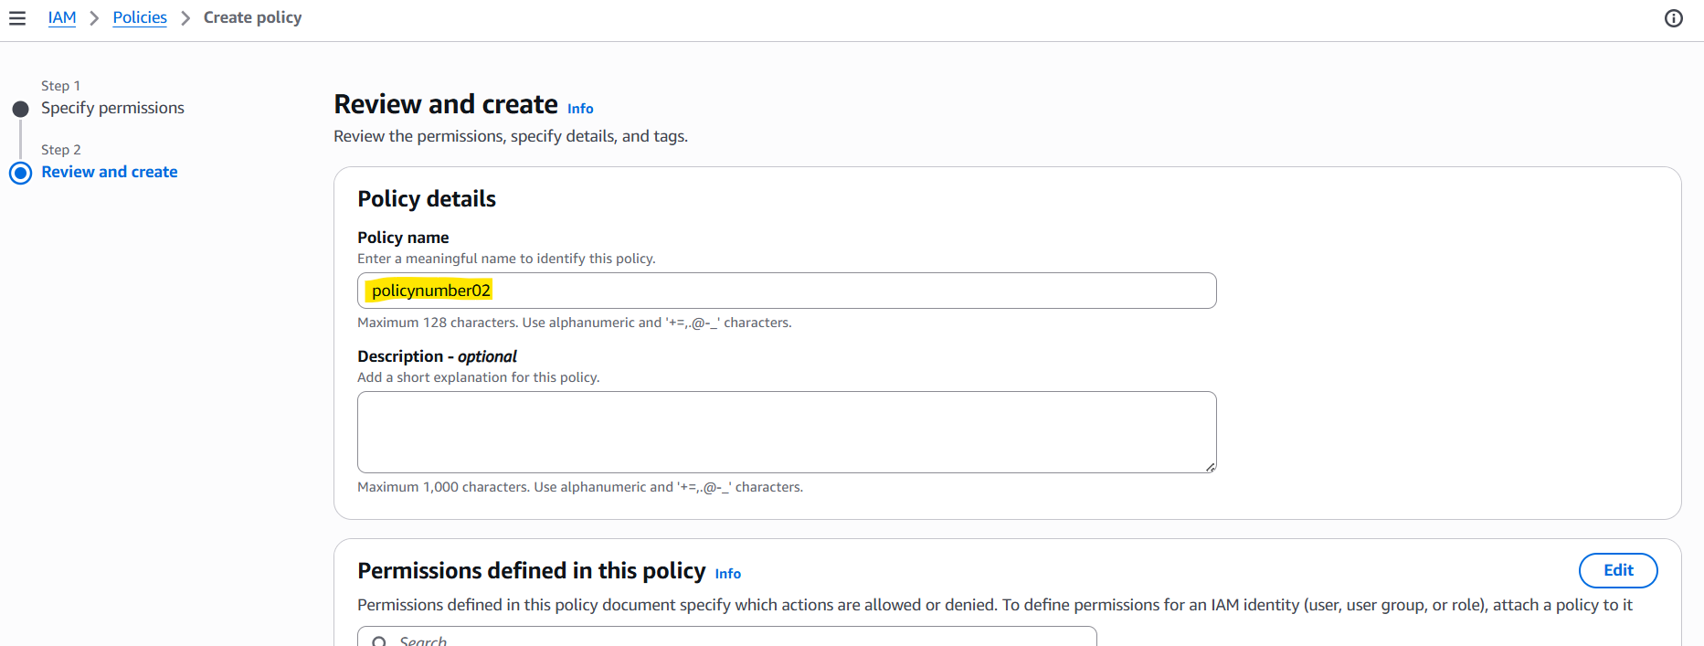

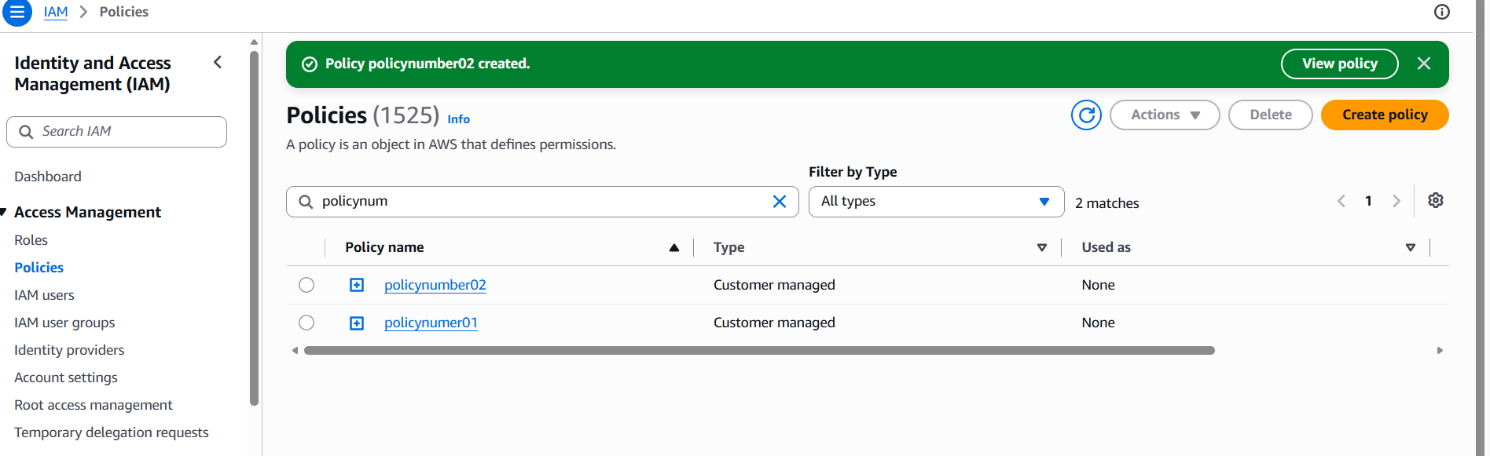
3. Attach policy number 1 to the Dev Team from task 1
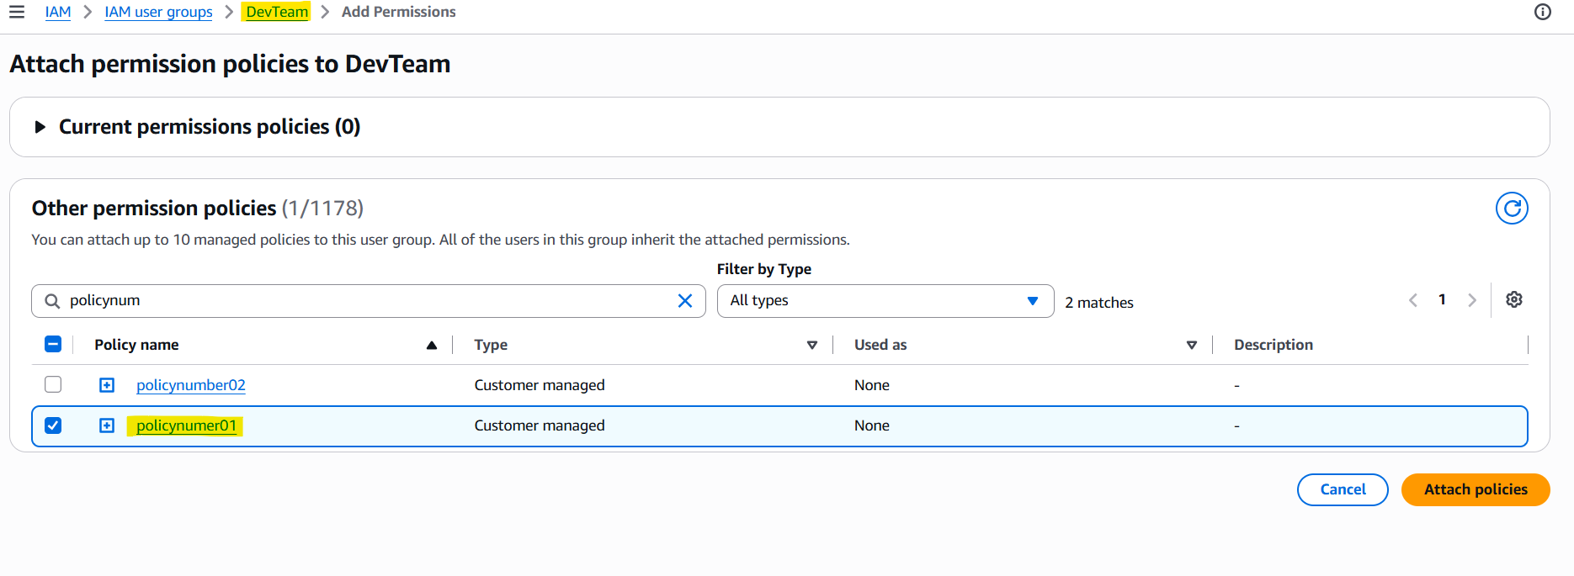
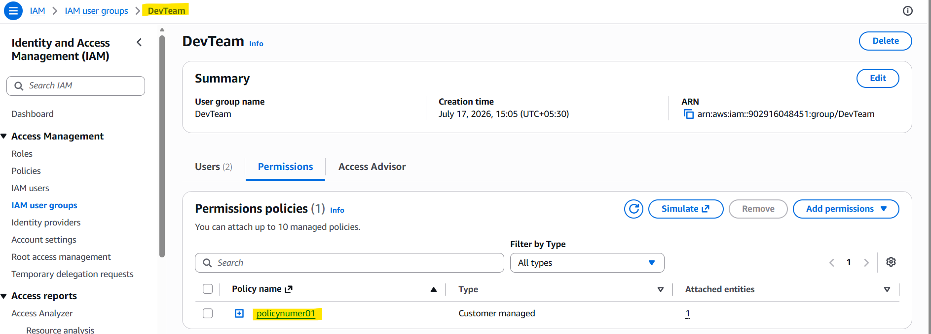
4. Attach policy number 2 to Ops Team from task1
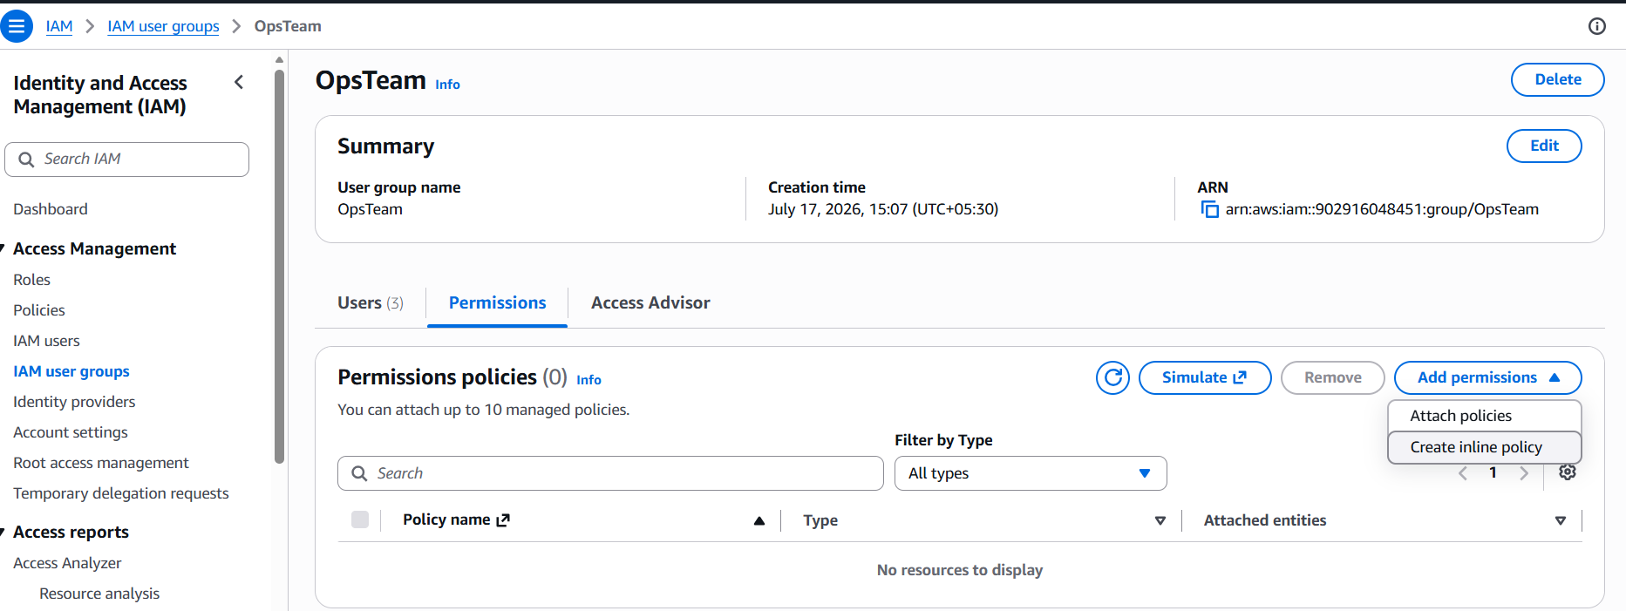

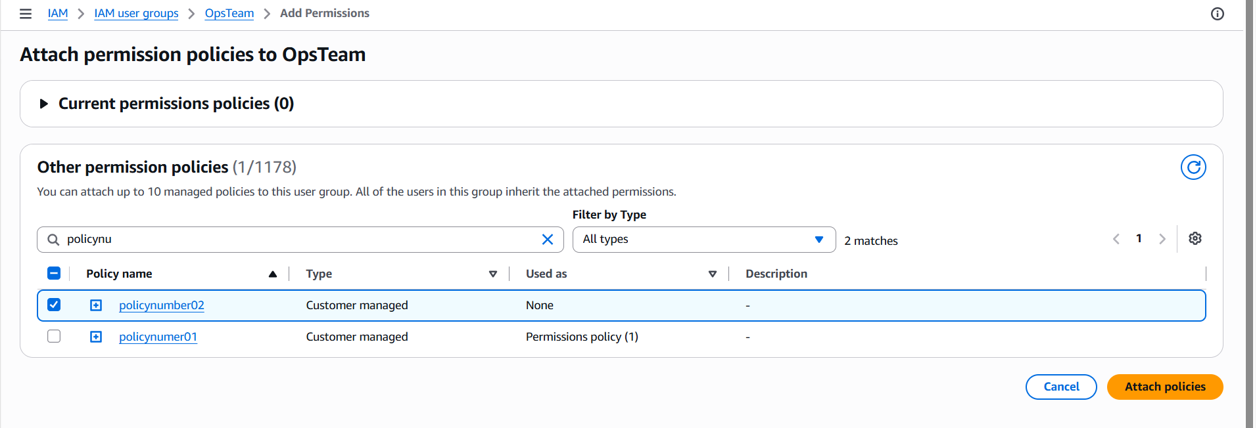

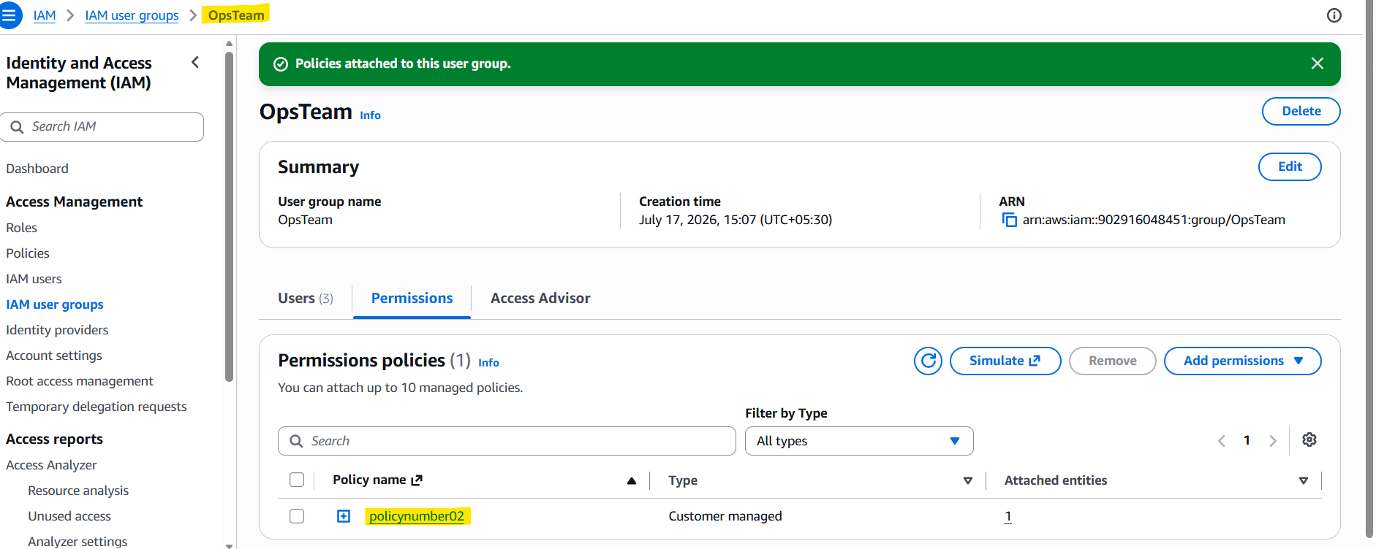
Validating for Dev2 user’s access for S3 bucket creation (Policynumber01):
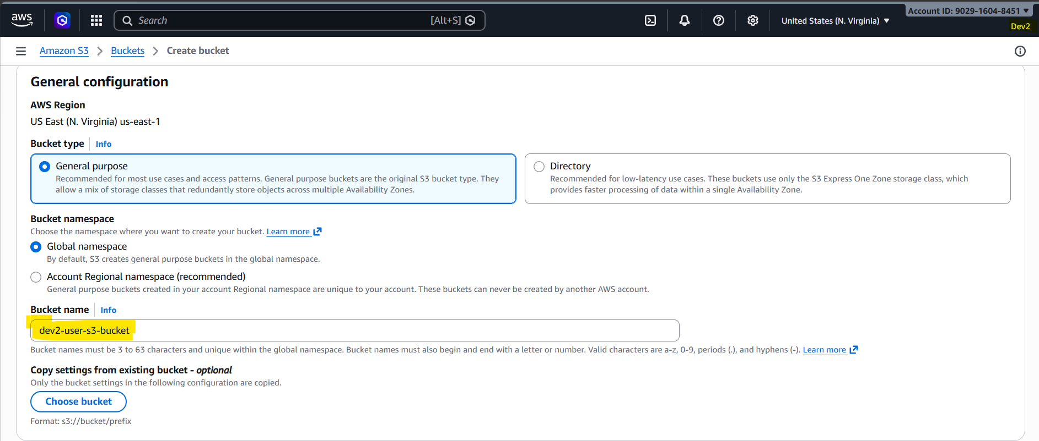

Validating for Dev2 user’s access for Redhsift (access not provisioned - Policynumber01):
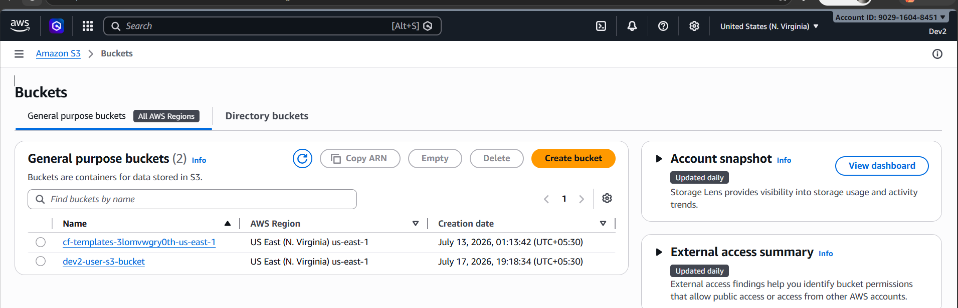
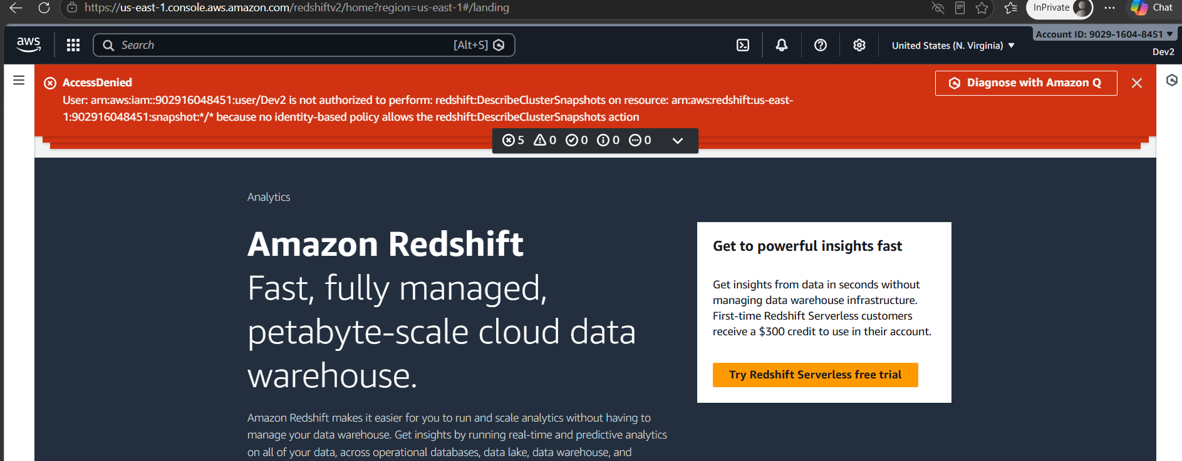
Policy number 2 Ops Team Test1: (Only List S3 but no other action is allowed)
Trying to upload the files in S3:
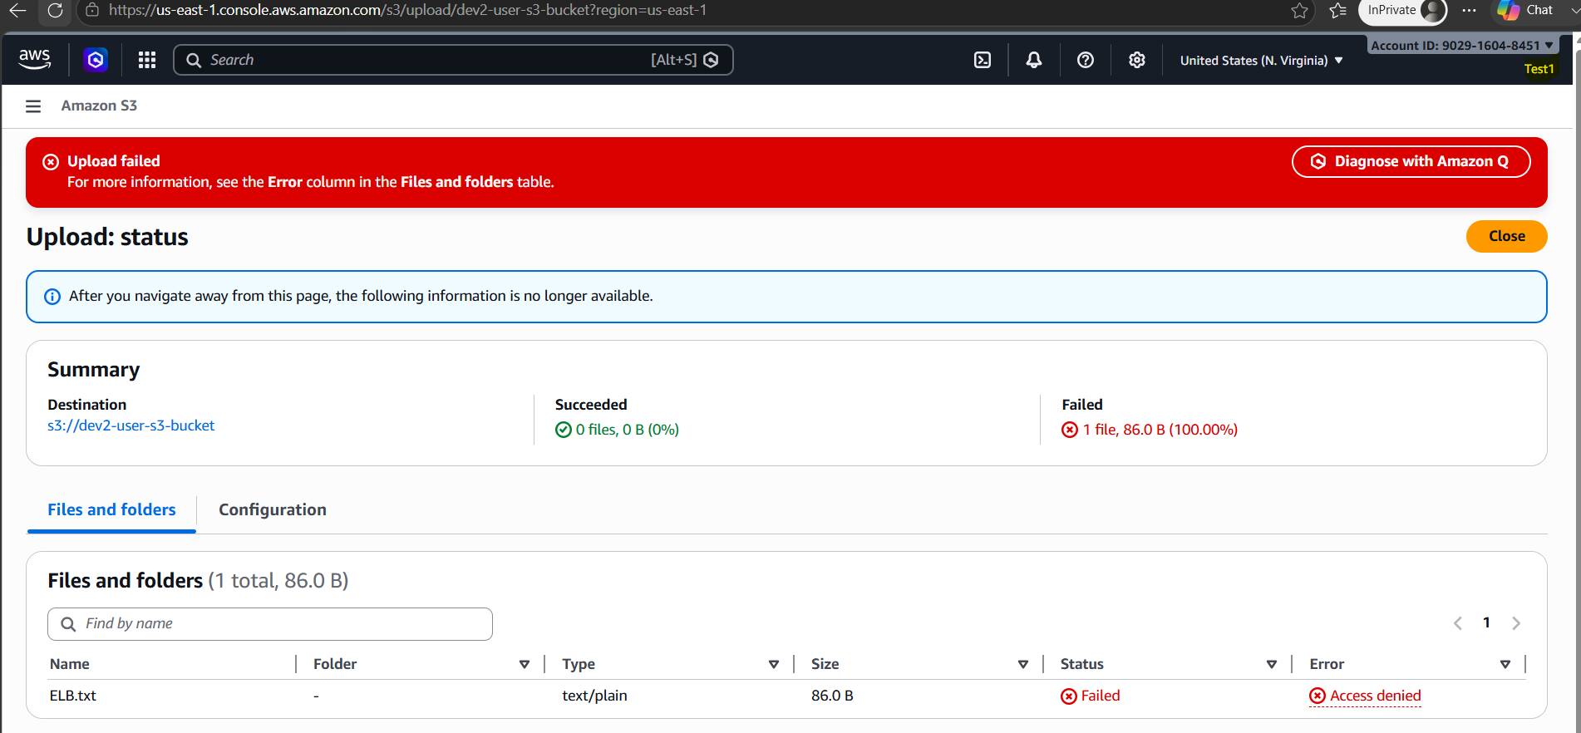

File upload failed as it is not provisioned:

